**Summary of Results of using Daubechies in Denoising Lung Sound with Noise using the Implemented Algorithm in the FPGA**

| **Daubechies** | | | | | | | |
| --- | --- | --- | --- | --- | --- | --- | --- |
| **Wavelet used** | | **SNR (dB)** | **SNR** | **RMSE** | **PRD** | **CC** | **Percentage Error** |
| **db2** | |  | | | | |  |
| **No. of Levels** | **2** | 23.3385 dB | 215.6999 | 0.00011089 | 6.8089% | 0.9446 | 9.3224% |
| **3** | 23.4978 dB | 223.7587 | 0.00010885 | 6.6851% | 0.94655 | 9.8408% |
| **4** | 23.8357 dB | 241.8633 | 0.0001047 | 6.43% | 0.95067 | 9.8553% |
| **5** | 24.1863 dB | 262.1984 | 0.00010054 | 6.1757% | 0.9546 | 9.5122% |
| **db3** | |  | | | | |  |
| **No. of Levels** | **2** | 23.442 dB | 220.9021 | 0.00010958 | 6.7282% | 0.94593 | 9.3510% |
| **3** | 23.8312 dB | 241.6128 | 0.00010475 | 6.4334% | 0.95056 | 6.8570% |
| **db4** | |  | | | | |  |
| **No. of Levels** | **2** | 23.609 dB | 229.5620 | 0.00010746 | 6.6001% | 0.94792 | 9.1782% |
| **db5** | |  | | | | |  |
| **No. of Levels** | **2** | 23.7664 dB | 238.0346 | 0.0001055 | 6.4815% | 0.94976 | 9.4893% |
| **db6** | |  | | | | |  |
| **No. of Levels** | **2** | 24.0297 dB | 252.9123 | 0.00010241 | 6.2881% | 0.9528 | 7.2999% |

**db2 - 2 level**

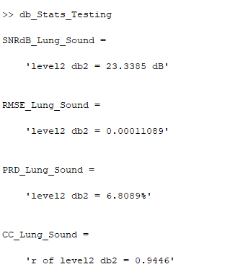

**db2 - 3 level**

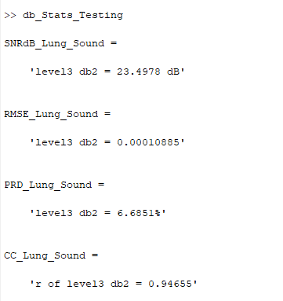

**db2 - 4 level**

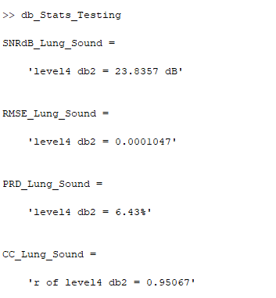

**db2 - 5 level**

**db3 - 2 level**

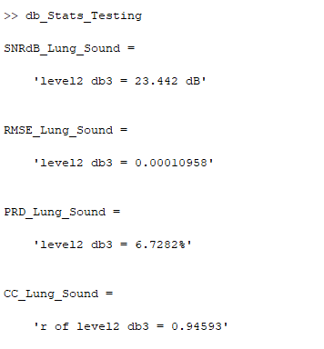

**db3 - 3 level**

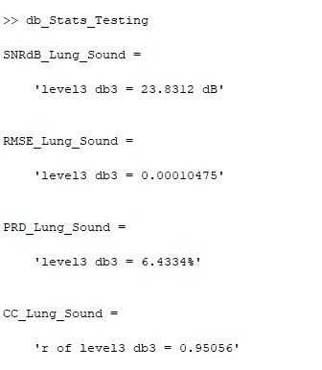

**db4 - 2 level**

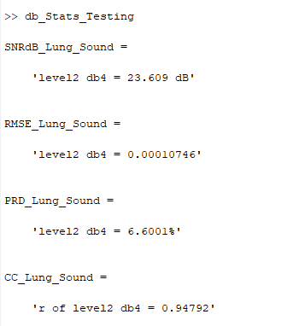

**db5 - 2 level**

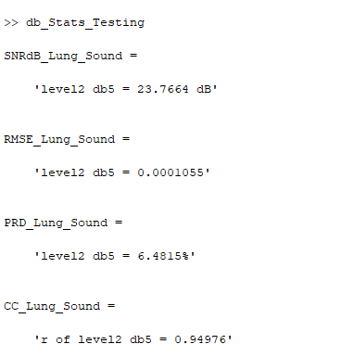

**db6 - 2 level**

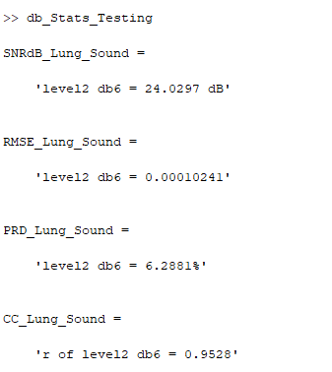

**Summary of Results of using Symlets in Denoising Lung Sound with Noise using the Implemented Algorithm in the FPGA**

| **Symlets** | | | | | | | |
| --- | --- | --- | --- | --- | --- | --- | --- |
| **Wavelet used** | | **SNR (dB)** | **SNR** | **RMSE** | **PRD** | **CC** | **Percentage Error** |
| **sym2** | |  | | | | | |
| **No. of Levels** | **2** | 23.5989 dB | 229.0287 | 0.0001076 | 6.6078% | 0.94781 | 8.9206% |
| **3** | 23.7543 dB | 237.3723 | 0.00010569 | 6.4906% | 0.94969 | 8.8808% |
| **4** | 24.2517 dB | 266.1767 | 9.9817e-05 | 6.1293% | 0.95514 | 9.3370% |
| **5** | 24.4053 dB | 275.7592 | 9.805e-05 | 6.0219% | 0.95667 | 9.4684% |
| **sym3** | |  | | | | | |
| **No. of Levels** | **2** | 23.867 dB | 243.6127 | 0.00010434 | 6.4069% | 0.95103 | 9.5830% |
| **3** | 24.1424 dB | 259.5613 | 0.00010104 | 6.207% | 0.95401 | 9.9363% |
| **sym4** | |  | | | | | |
| **No. of Levels** | **2** | 24.1945 dB | 262.6939 | 0.00010046 | 6.1698% | 0.95448 | 8.9311% |
| **sym5** | |  | | | | | |
| **No. of Levels** | **2** | 24.2554 dB | 266.4035 | 9.9773e-05 | 6.1267% | 0.95524 | 9.8159% |

**Sym 2 - level 2**

**Sym 2 - level 3**

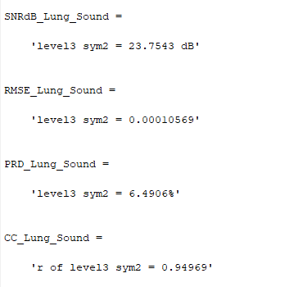

**Sym 2 - level 4**

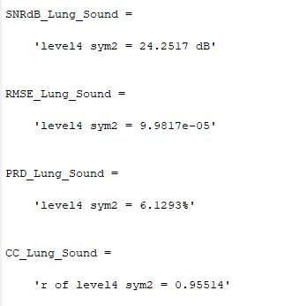

**Sym 2 - level 5**

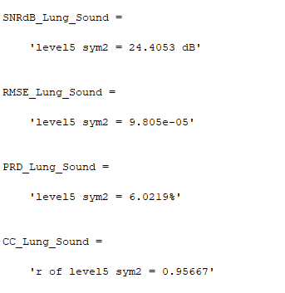

**Sym 3 - level 2**

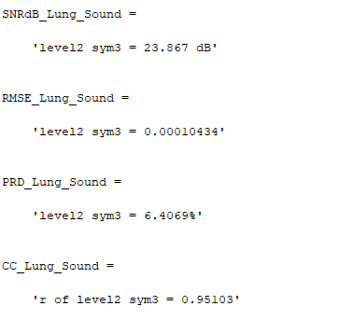

**Sym 3 - level 3**

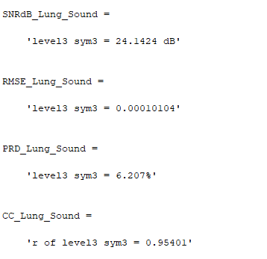

**Sym 4 - level 2**

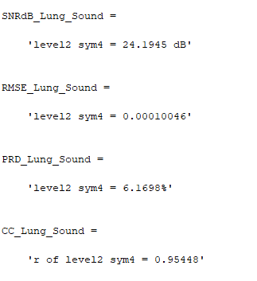

**Sym 5 - level 2**

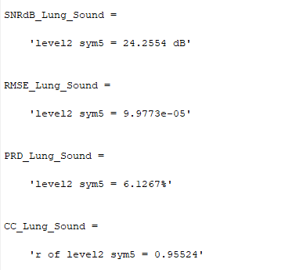

**Summary of Results of using Coiflets in Denoising Lung Sound with Noise using the Implemented Algorithm in the FPGA**

| **Coiflets** | | | | | | | |
| --- | --- | --- | --- | --- | --- | --- | --- |
| **Wavelet used** | | **SNR (dB)** | **SNR** | **RMSE** | **PRD** | **CC** | **Percentage Error** |
| **coif1** | |  | | | | | |
| **No. of Levels** | **2** | 24.7564 dB | 279.04 | 0.000094161 | 5.7834% | 0.95985 | 7.147% |
| **3** | 24.2853 dB | 295.49 | 0.000099432 | 6.1057% | 0.95548 | 9.2221% |
| **coif2** | |  | | | | | |
| **No. of Levels** | **2** | 24.1206 dB | 284.22 | 0.00010131 | 6.22% | 0.95369 | 9.1322% |

**Coif 1 - level 2**

**Coif 1 - level 3**

**Coif 2 - level 2**